**PLANNING THE TECHNICAL FOUNDATION**

**Comforty Furniture Website System Architecture**

# Overview

Comforty is an e-commerce platform specializing in stylish and comfortable chairs for various needs. The platform is built using **Next.js 14 with TypeScript** for optimal performance and **Sanity CMS** to manage content seamlessly. Below is the detailed system architecture designed to ensure scalability, maintainability, and a superior user experience.

## High-Level System Architecture

# Frontend Structure

**Framework:** Next.js 14 with TypeScript for fast server-side rendering (SSR) and dynamic routing.

**Key Pages:**

* **Home:** Showcases featured chair categories, trending products, and ongoing promotions.
* **Product Listing:** Displays all chair collections with filtering options (e.g., by type, material, price).
* **Product Details:** Dynamic page for individual chair details, including images, descriptions, and reviews.
* **Cart:** Shows selected products, allowing users to adjust quantities and view order summaries.
* **Checkout:** Securely handles payment and shipping information.
* **Order Confirmation:** Displays purchase confirmation and order details.
* **Admin Panel:** Reserved for admin tasks, including stock management, order tracking, and user analytics.

## User-Specific Pages:

* **Login/Sign Up:** Facilitates secure user authentication.
* **User Dashboard:** Provides order history, shipment tracking, and saved preferences.

## Admin-Specific Pages:

* **Analytics:** Visualizes sales trends, revenue, and product performance. ● **Stock Management:** Displays inventory data and low-stock alerts.
* **Order Management:** Tracks orders and shipping progress.

## Reusable Components:

* **ProductCard.tsx:** Renders chair details (image, name, price, label, ) across pages.
* **HeroSection.tsx, PopularProducts.tsx:** Key sections of the homepage to highlight Comforty’s unique offerings.
* **Filters.tsx:** Provides sorting options for the product listing page.

# CMS (Sanity)

**Sanity Studio** is utilized for backend management:

* **Products:** Schema includes product name, price, stock, materials, dimensions, and images.
* **Customers:** Stores login credentials, order history, and saved items.
* **Orders:** Tracks order details, including purchased products, payment status, and shipping information.
* **Inventory:** Manages product availability in real time.

# Data Management Features:

* **Custom Schemas:** Tailored to store and retrieve data for chairs, orders, and user accounts.
* **GROQ Queries:** Fetch real-time product and inventory data for seamless frontend updates.

### Third-Party API Integrations

1. **Payment Gateway (Stripe):** 
   1. Handles secure payment transactions with support for credit/debit cards and digital wallets.

○ Utilizes **Stripe Elements** for collecting and validating payment details.

1. **Shipment Tracking (Shippo API):** 
   1. Enables real-time shipment updates for customers. ○ API Endpoints:

■**/api/products:** List available products.

■**/api/shipment:** Create and manage shipments.

■**/api/livetracking:** Real-time shipment tracking.

1. **Email Notifications:** 
   1. Integrates services like **SendGrid** to send order confirmation and shipping updates to customers.

## Architecture Diagram

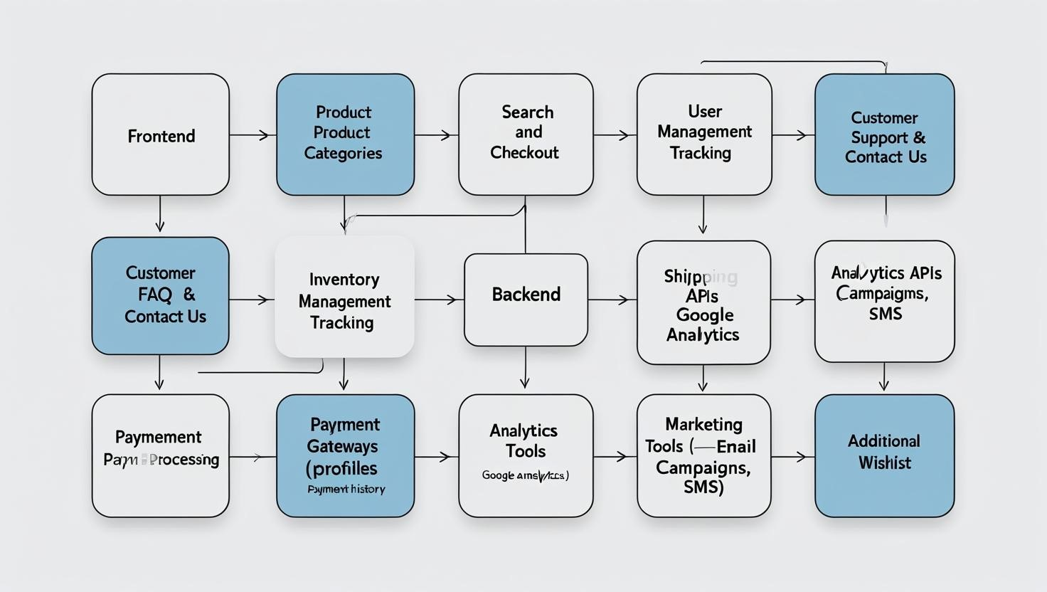

### Workflow Overview

**User Workflow:**

1. **Browse Products:** 
   1. Users view products fetched dynamically from Sanity via APIs.

○ Filters allow refined browsing by type, material, and price.

1. **Add to Cart:** 
   1. Users add chairs to their cart; the data is stored locally or synced to their profile after login.
2. **Checkout Process:** 
   1. CheckoutModal.tsx securely collects payment and shipping information.
3. **Order Confirmation and Tracking:** 
   1. Users receive an order summary and can track shipments through the user dashboard.

### Admin Workflow:

1. **Login:** 
   1. Admins log in securely to access the admin panel.
2. **Data Management:** 
   1. Manage inventory, monitor stock levels, and update product information via Sanity.
3. **Analytics and Trends:** 
   1. Analyze sales data and customer behavior to inform business decisions.

### Technologies and Tools

* **Frontend:** Next.js 14 with TypeScript
* **CMS:** Sanity
* **Payment Gateway:** Stripe
* **Shipment Tracking:** Shippo API
* **Hosting:** Vercel for fast and reliable deployment

### Folder Structure

/project-root

/src

/app

/home (Homepage components)

/products (Product listing and filters)

/product/[id] (Dynamic product details)

/cart (Shopping cart page)

/checkout (Checkout process) /admin (Admin panel)

/sanity

/schemas (Product, Order, User schemas)

/components

/HeroSection.tsx

/ProductCard.tsx

/CartItem.tsx

/orderSystem

/CheckoutModal.tsx /PaymentForm.tsx

## Workflow Diagram

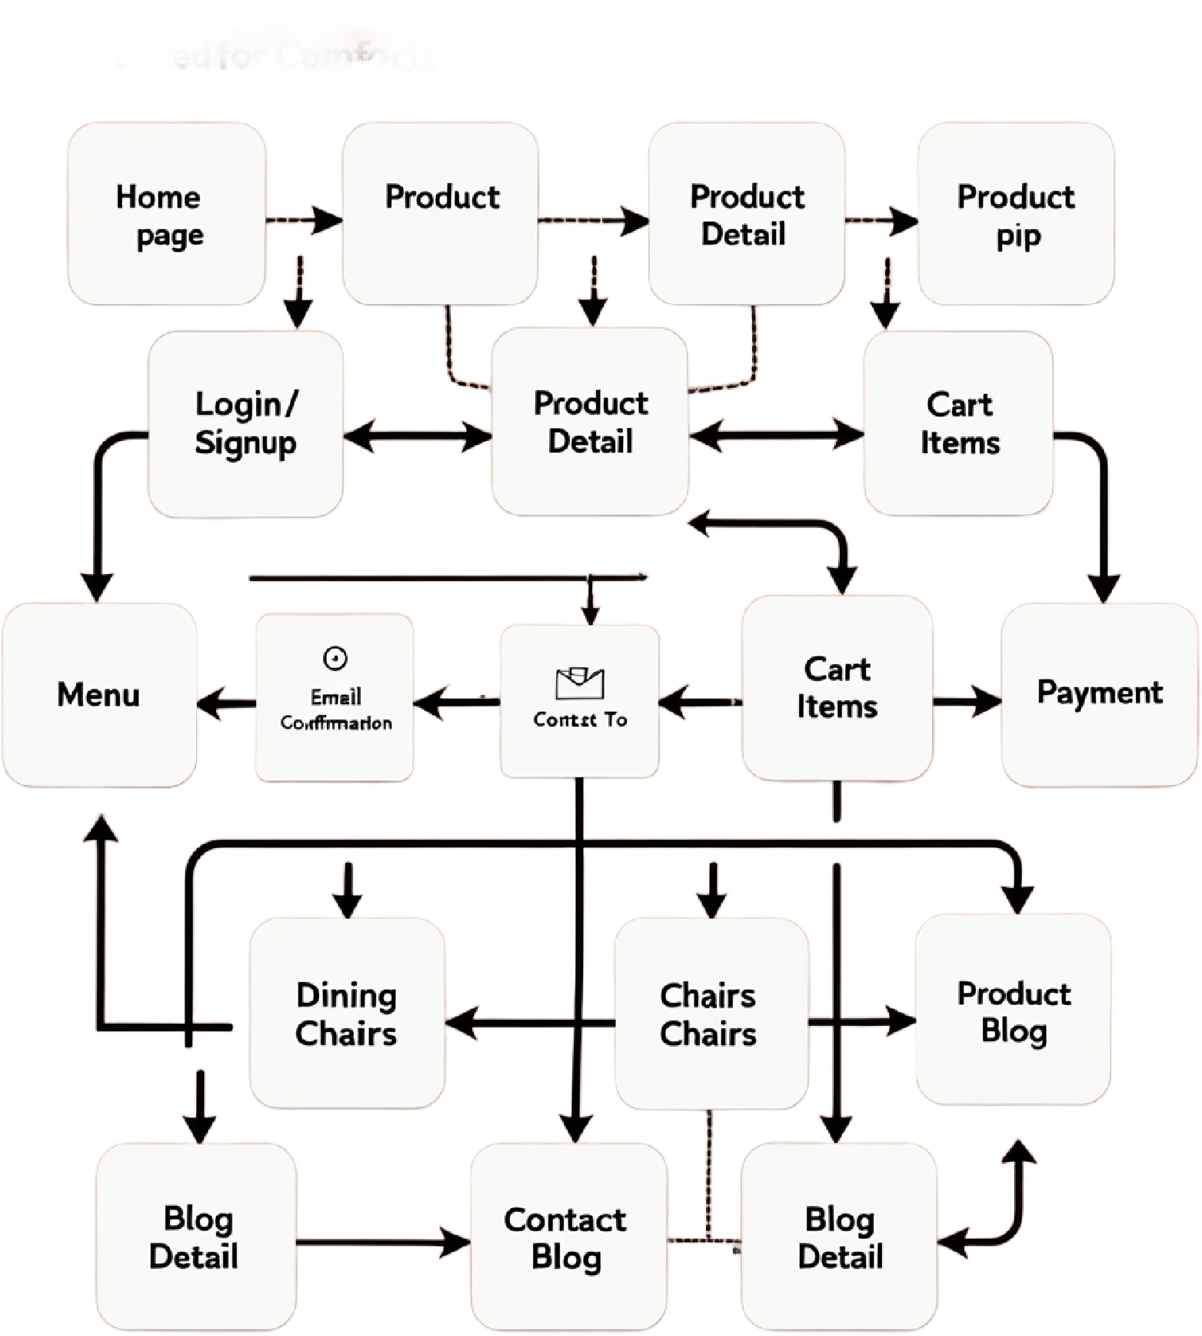

### Data Flow

1. **Products:** Fetched from San CMS and displayed dynamically.
2. **Cart:** Items stored in local storage or synced to the user profile after login.
3. **Orders:** Stored in Sanity CMS and accessible by both users and admins.
4. **Payments:** Processed through Stripe with webhook support for updates.
5. **Shipments:** Managed using Shippo API for real-time tracking.

**Conclusion**

This system architecture ensures that Comforty provides a user-friendly experience while maintaining scalability and flexibility. Leveraging Next.js, Sanity, Stripe, and Shippo establishes a robust foundation for smooth operations, efficient data management, and a delightful customer journey.

**Prepared By: Murtaza Hasnain**